Water Strand Pre-Post 2012-2013 – Version A

Please put your initials (not your full name) in the boxes.
First | Middle | Last
Date ________________

LTER Site ____________________

Engineered Systems
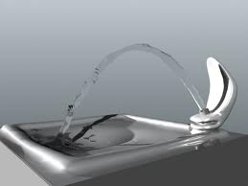

- Where does the water that is used in your school come from? Please explain how it gets to your school. Trace back as many steps as you can.

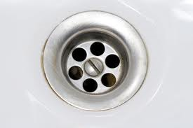

- Where does the waste water from your school go? Please explain how it gets to where it is going. Trace forward as many steps as you can.

Pie Chart Questions
The pie chart below describes where water goes on your school grounds when it rains. Use the pie charts to answer questions 3, 4, & 5.
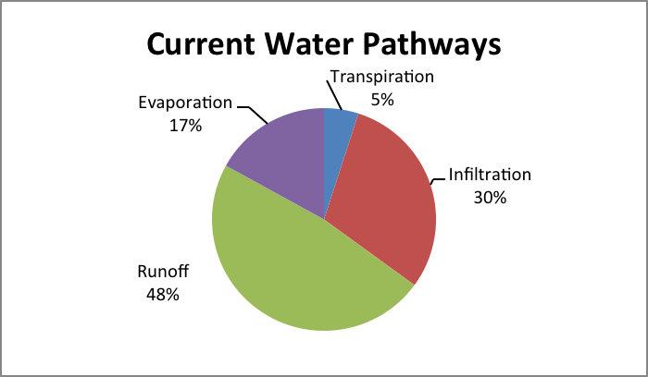

- Your school is considering replacing part of the school parking lot with an open space of grass and trees. Before the decision is made to do this, however, the potential impacts of this change on the water budget have to be considered. Which of the pie charts below best fits the result that would be most likely? (Circle the letter next to the chart).

A | 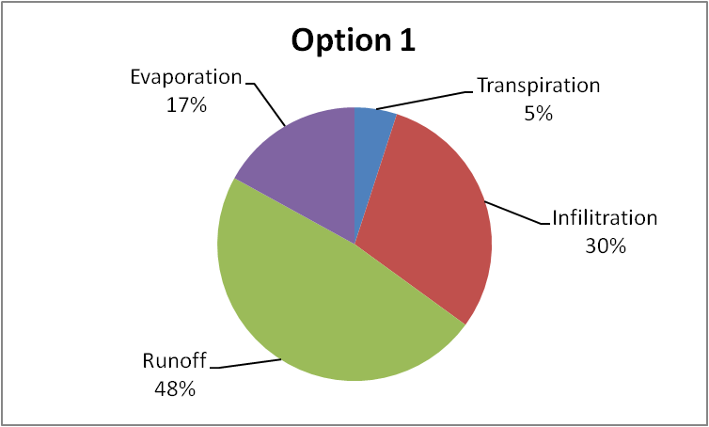 | C | 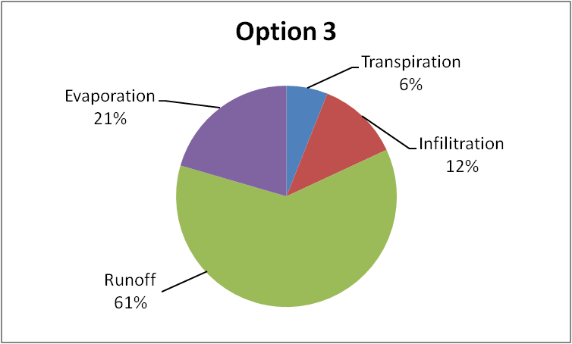
B | 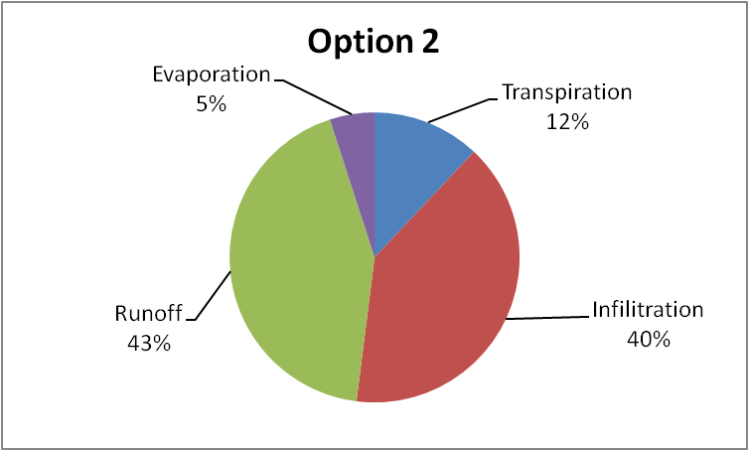

- Please explain what happened to the amounts of infiltration and runoff. Include the reasons why.

- Please explain what happened to the amounts of evaporation and transpiration. Include the reasons why.

Tree Questions
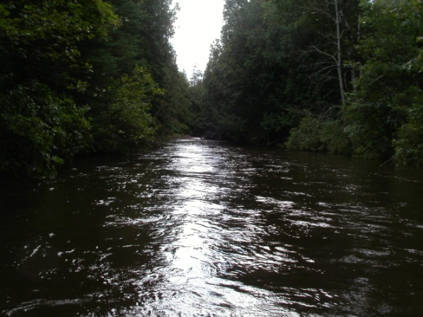
Like many rivers, the Sturgeon River in northern Michigan has lots of large trees growing along its banks.

- A large tree can pull in 200 gallons of water a day. What happens to the 200 gallons of water that the tree pulls in? Please fill in the table below.
List one place that the water the tree pulls in could go. Explain how it gets there and why it goes there. | How much of the water that the tree uses would go there?  All Most  Half A little
List a second place that the water the tree pulls in could go. Explain how it gets there and why it goes there. | How much of the water that the tree uses would go there? (all, most, half, a little)  All Most  Half A little

- What would happen to the amount of water in the Sturgeon River if all of the trees died or were cut down? Be sure to explain how this would happen and why.

Substances Questions
The picture below shows part of a school campus with several grassy playing fields near a river. Use the picture to answer questions 8, 9, and 10.
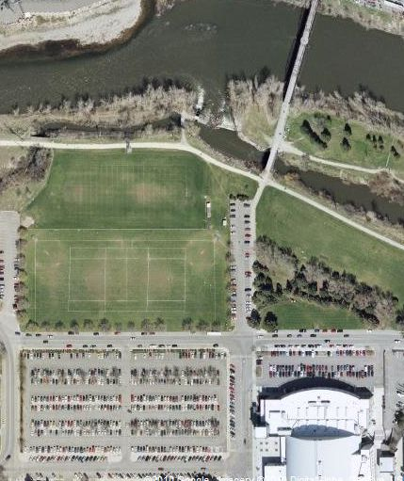

- A. If the playing fields were treated with fertilizer, do you think that some of the fertilizer could get into the river?
(Circle one) YES NO
If you think yes, explain how and why the fertilizer could get into the river. If you think no, explain why fertilizer would not get into the river.

- What is in the fertilizer that could get in the river? (In other words, what is fertilizer made of?)

- If some of the fertilizer got into the river, how would the fertilizer affect the river water and living things in the river?

River Map Questions
Use the map below to answer questions 11 and 12.
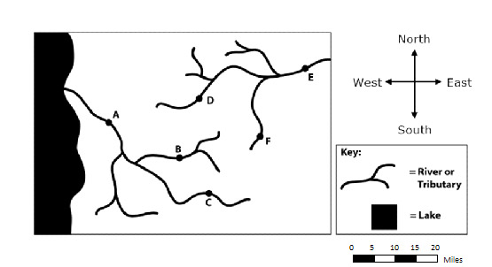
- Can pollution in the river water at Town B get to Town C?
(circle one) Yes No
Explain why or why not.

- Draw an arrow showing the direction water is flowing away from Town F. How do you know the water is flowing this direction?

Soccer Game Questions
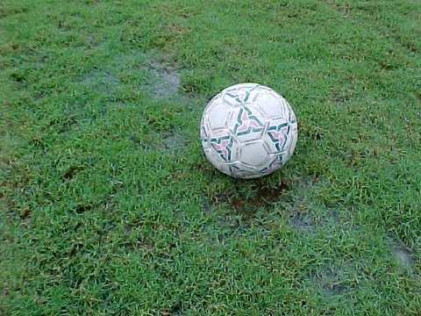
Your soccer game gets canceled at half time due to a massive down pouring of rain. As you run for cover, you notice that there are large puddles forming on the grass covered playing field, but no puddles forming in the sand covered playground just a few steps away.

- Why are there puddles on the grass and not on the sand?

- Explain what happens to the water that lands on the sandy playground? Be sure to explain how and why.

- The next week you come back to the soccer field and you notice there is no water on the grassy field. Explain what happened to that water? Be sure to explain how and why.

